Introduction to Java 1

Exercises

Name - Prashant Brahmbhatt

Newer ID - 4092

Email - [prashant.brahmbhatt@tothenew.com](mailto:prashant.brahmbhatt@tothenew.com)

1. Write a program to replace a substring inside a string with another string ?

ANS: Filename StringReplace.java

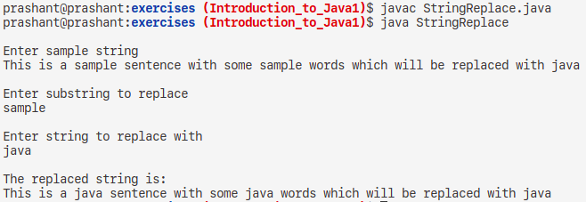

1. Write a program to find the number of occurrences of the duplicate words in a string and print them ?

ANS: Filename DuplicateWords.java

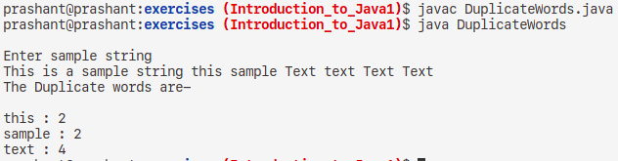

1. Write a program to find the number of occurrences of a character in a string without using loop?

ANS: Filename DuplicateCharWoLoop.java

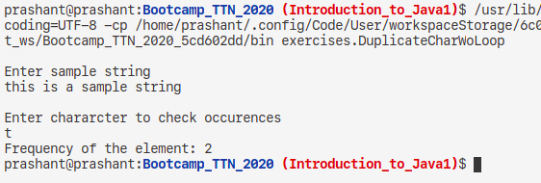

1. Calculate the number & Percentage Of Lowercase Letters,Uppercase Letters, Digits And Other Special Characters In A String.

ANS: Filename GroupCharCount.java

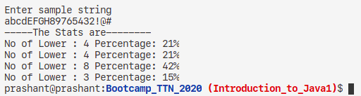

1. Find common elements between two arrays.

ANS: Filename ArrayCommon.java

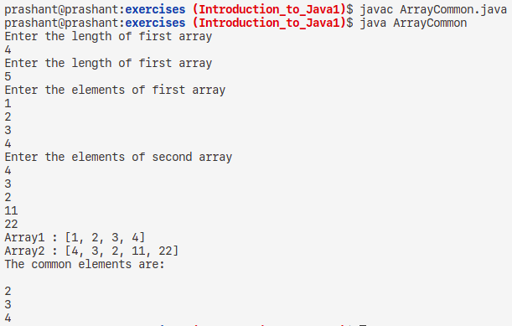

1. There is an array with every element repeated twice except one. Find that element.

ANS: Filename FindSingle.java

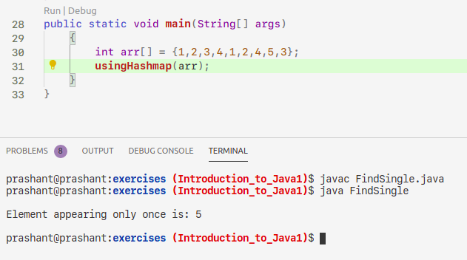

1. Write a program to print your Firstname,LastName & age using static block,static method & static variable respectively.

ANS: Filename AllStatic.java

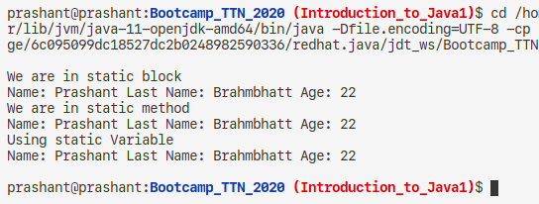

1. Write a program to reverse a string and remove character from index 4 to index 9 from the reversed string using String Buffer.

ANS: Filename ReverseRemove.java

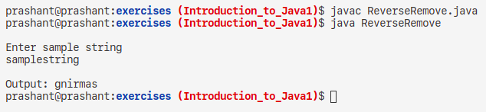

1. Write a program to display values of enums using a constructor & getPrice() method (Example display house & their prices)

ANS: Filename EnumHouses.java

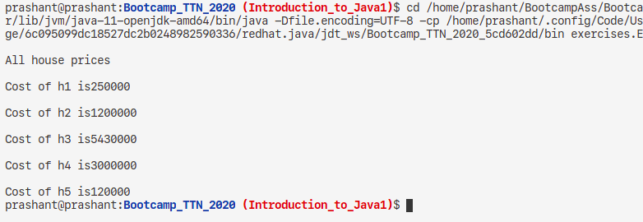

1. Write a single program for following operation using overloading

A) Adding 2 integer number

B) Adding 2 double

C) multiplying 2 float

D) multiplying 2 int

E) concate 2 string

F) concate 3 String

ANS: Filename MethodOverloading.java

